Assignment – General Purpose utilities in Linux

1)Display the calender for the month of March 2012

Ans: cal 03 2012

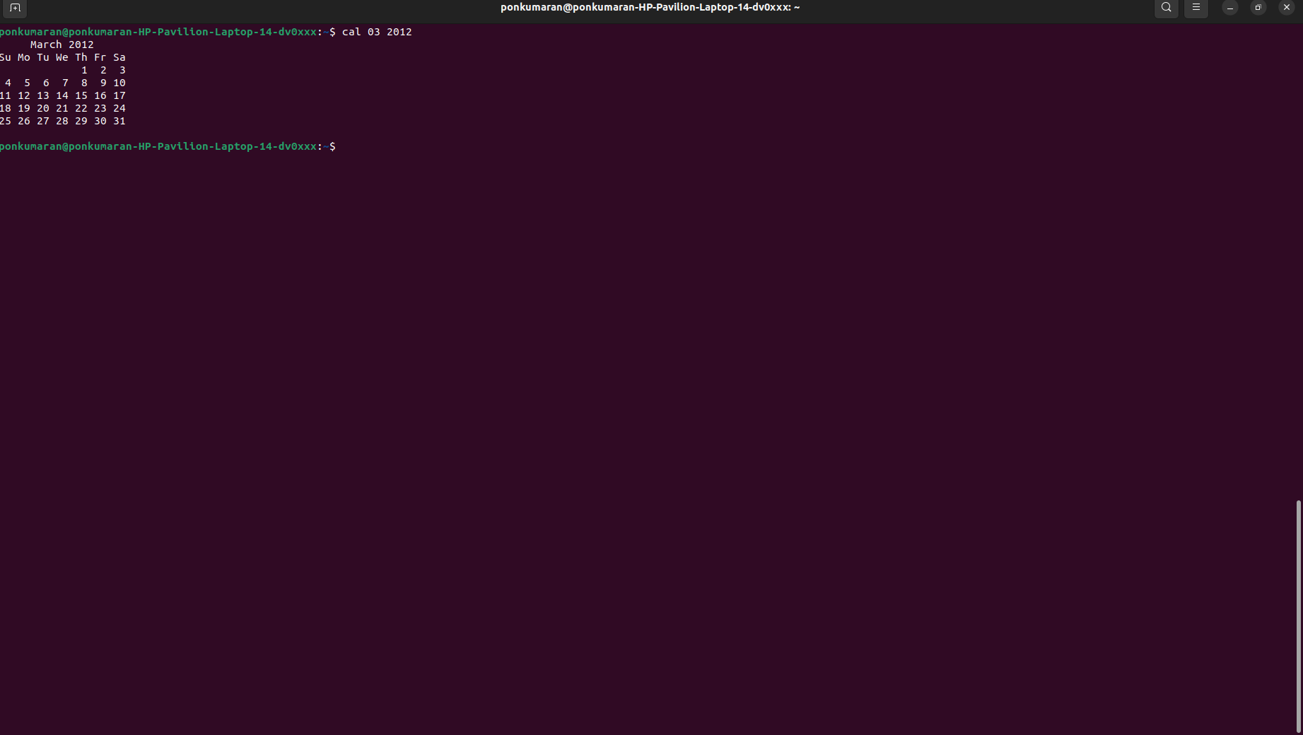
2)List all the files and directories of the directory /usr/lib on the terminal. Now put the same information in a file named results.
2. List all the files and directories of the directory /usr/lib on the terminal. Now put the same information in a file named results.
Display the contents of the file results now.
Ans: ls usr/lib > results.txt
